1. **Proposed system**
   1. **Definition: -**

This system is used to encourage learners who want to improve their knowledge in the domains of computers science by reading books, articles or by enrolling into the courses of their interested domain of computer science. They can also place their queries or questions related to computer science in a discussion forum.

* 1. **Purpose: -**

The main purpose of this system is to improve online studies and learning of computer science learners to get more out of online studies and to provide more and more content using user’s daily reading activities.

* 1. **Scope: -**

This system is used by only those learners who are learning only in computer science to improve their knowledge in particular domains.

* 1. **Extended features: -**
* **Article: -**

User can read and upload article in to this system. Using this features user can improve their self in particular domain of computer science.

* **Book: -**

User can read and upload book in to this system. Using this features user can improve their self in particular domain of computer science. Book is available in pdf format.

* **Forum: -**

Using this features, user can upload their question on forum. For upload the question, first of all user should be select the domain. After they can upload the question in particular domain.

* **Domain: -**

Using this features, user can find their interested domain’s book and articles.

* **Use tags: -**

Tags are used for suggesting courses, articles, and books and it also used for fast searching on the website.

* **Online course portal: -**

Learners can have enrolled in given course that are uploaded by domain expert and expert can track student information. Also learners can track their certifications and skill on their completed course also it helps to provides an advanced recommendation that what learners can do after completing a particular course that they completed recently.

* **Motivational triggers: -**

This feature motivates learners to find an answer to a given question they can find answers from books, articles, or from another online source.

* **Recommended more resources using tags: -**

This feature also includes tags to suggest relevant content to the user. Suggestion is added from the user's daily readings in the system.

* **Online compiler: -**

Learner can compile their code in give online compiler without downloading any software or plugin

* **Gamification: -**

This feature includes challenges, levels, instant feedback, scores, competition provided in the course to motivate learners to spend more time learning more things on our websites.

* 1. **Limitation: -**
* User can compile their code on online compiler only for three time per day.
* Only 100 users can successfully log in to the system per day.
  1. **Functional Requirements: -**
* Create an account: - This functionality creates a new account by filling the registration detail for the user.
* Users can update his or her profile.
* Users can provide research articles in particular courses if its mandatory.
* Users can get notifications about the articles according to their interest in self-improvement, time management, problem-solving, etc.
* Admin maintains all registered users’ details and can use it for users’ better performance.
* Admin can remove users' indiscipline according to the teacher’s feedback.
* Admin solves all problems of users regarding their feedback.
* Multiple tag can be added to the particular courses, articles, books and forum question.
* User can compile their code in the given online compiler and verify if it run successfully or not.
* Users can add or enrolled into the courses that are added into the system.
* learner can track their certificate and skills improvement by completing any particular course.
  1. **Non-functional Requirements: -**
* Security: - Only authorized user can access the system with username and password. password will be store in encryption format in database.
* Performance: - As system provide fast performance so, user can quickly access this system.
* Availability: - System is available 24*7 for the user.
* User-friendly Interface: -The system is interactive for any user and provide responsive design.
* Suggest materials: - this system stores user's daily activity like what article, book, forum is most opened by the user, and after storing this data system suggests more that type of content to that user
  1. **Tools and Technology: -**
* HTML (Version: 5.0)
* CSS (Version: 5.0)
* JavaScript
* PHP (Version: 7.4.5)
* MySQL (Version: 8.0)
  1. **User with their characteristics**
* **Admin: -**
* Login: -Admin can log in to the system.
* Manage profile: -Admin can manage their profile.
* Manage domain: -Admin can manage domains of computer science (IT).
* Manage user: -Admin can manage domain experts and learners.
* Manage forum: -Admin can manage discussion forum.
* Manage tag: - Admin can manage tag like update and delete tag in the system.
* View course list: - Admin can only view course list. They can’t update it.
* Add motivational triggers: - Admin can add motivational triggers in the system and also update it.
* **Domain expert: -**
* Login: -An expert can register themselves into the system and after that, they can log in the system.
* Manage profile: -Experts can manage the profile.
* Manage forum: -Experts can provide the questions on the discussion forum and also solve the queries which are posted in the forum.
* Manage material: -They can manage learning materials like books, Articles.
* Approve/Reject question: - Experts can approve/reject topics/questions add by the learner.
* Manage course: - Expert can manage courses in the system.
* View motivational triggers: - Expert can only see the motivational triggers. They can’t update it.
* **Learner: -**
* Login: -The learner can register themselves into the system and after that, they can log in the system.
* Manage profile: -Learners can manage the profile.
* View article: -The learner can view articles/books of their interested domain.
* Upload question on forum: -The learners can add their query on the topics/questions which are already uploaded in the discussion forum.
* Send request: - Learner can send a request for any question and also can comments on any question.
* Enrolled course: -Learner can enrolled in the system by pay some money or free.
* View and give answer of motivational trigger: -Learner can view and give answer of motivational triggers.

1. **System Process Flow**
   1. **Use-Case Diagram: -**

* **Admin**

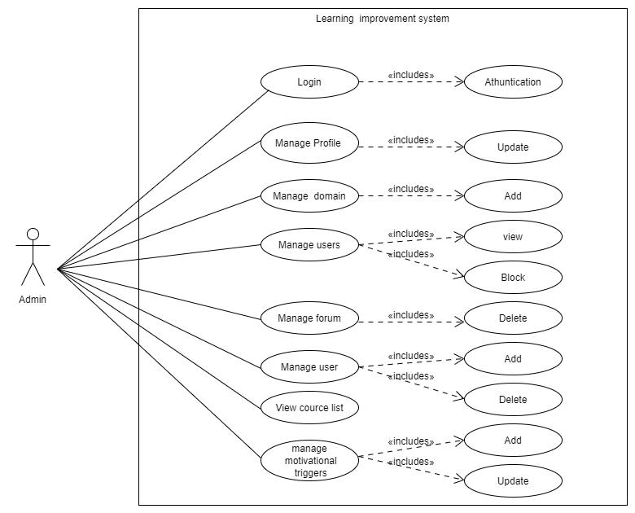

Figure 1 Use-case of Admin

* **Domain Expert**

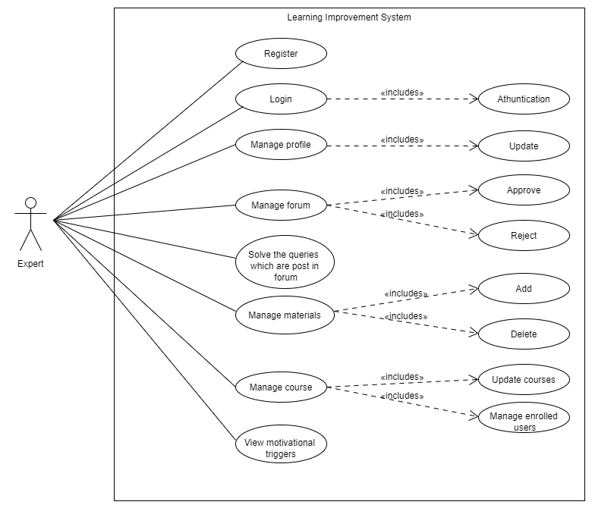

Figure 2 Use-case of Domain expert

* **Learner**

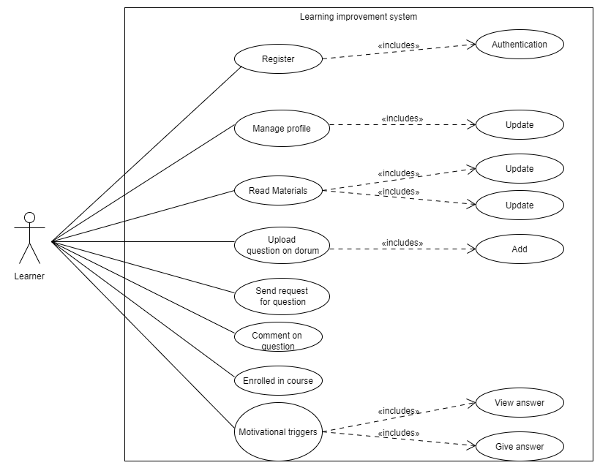

Figure 3Use-case of Learner

* 1. **Activity Diagram: -**
* **Registration activity**

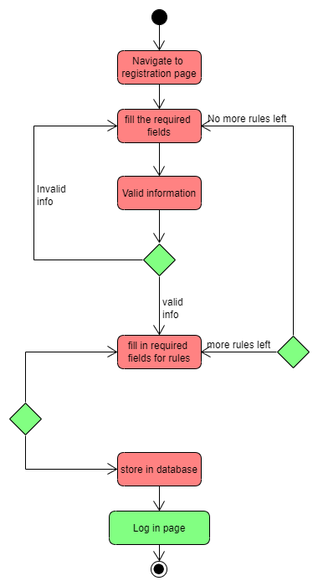

Figure 4 Registration activity

* **Login activity**

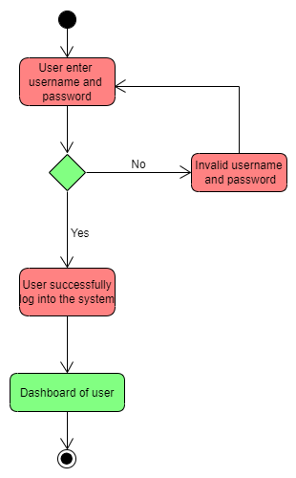

Figure 5 Login activity

* **Add book activity**

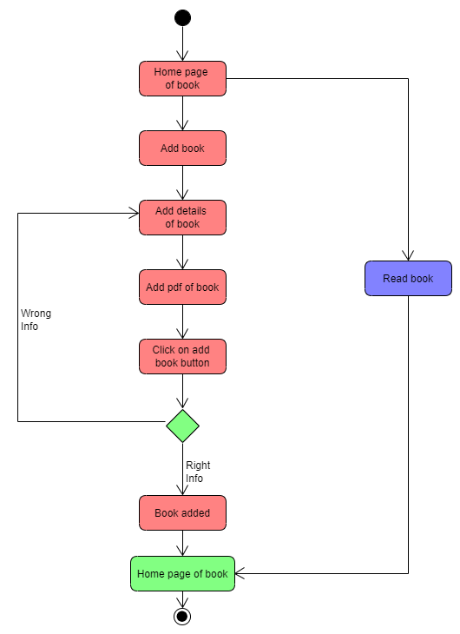

Figure 6 Add book activity

* **Add article activity**

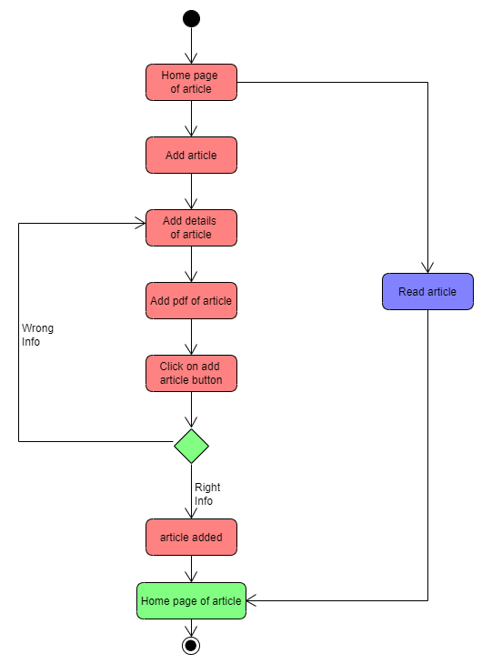

Figure 7 Add article activity

* **Add question on forum activity**

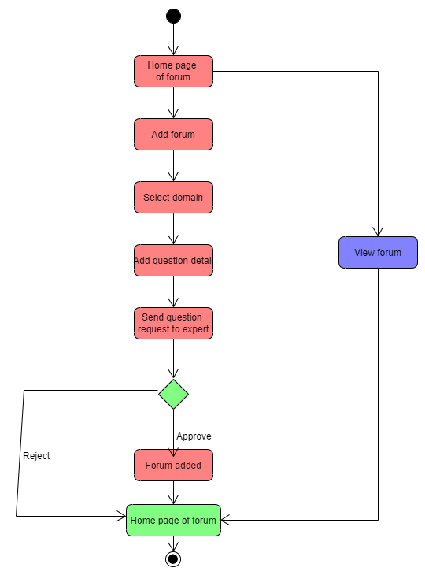

Figure 8 Add forum activity

1. **System Design**
   1. **Data modeling**

Software Development model

**Model Name**: Incremental model is used in this system

**What is incremental model:**

The incremental build model is a method of software development where the product is designed, implemented and tested incrementally (a little more is added each time) until the product is finished. It involves both development and maintenance.

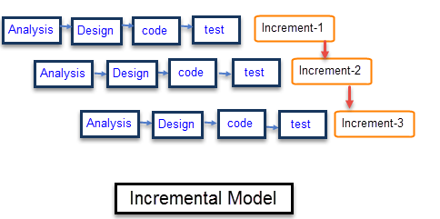

Figure 9 Incremental model

**Why Learning system use this model:**

This system is created in very basic and some unique features when this version is start its working successfully. we start working on its next updated version with some more functionality and those all version(modules) are implemented and delivered until the desired system is not released.

First Module of this system contains features like type vise user registration, admin side home page, article drafting and book uploading in the system

Second Module of this system contains fixing of some errors of 1st module and it also contains forum drafting page, domain vise forums etc.

* 1. **Data Dictionary**
     1. **Data_user**

***Table 1 User***

|  |  |  |  |
| --- | --- | --- | --- |
| **Field_name** | **Data_type** | **Constraints** | **Sample_value** |
| User_id | INT(11) | PRIMARY KEY auto_increment | 01 |
| User_name | VARCHAR (30) | NOT NULL | Abc_123 |
| User_email_id | VARCHAR (20) | NOT NULL | abc01@gmail.com |
| User_password | VARCHAR (700) | NOT NULL | abc@123 |
| User_type | CHAR (1) | NOT NULL | E / L |

**Purpose of the table: -**

In this database table, it stores all the major information of the User. In this table we will store UserId, User_name, User_email_id, User_password, User_type of the user.

* + 1. **data_domain_expert**

***Table 2 Domain expert***

|  |  |  |  |
| --- | --- | --- | --- |
| **Field_name** | **Data_type** | **Constraints** | **Sample_value** |
| Expert_id | INT(11) | FOREIGN KEY | 01 |
| Expert_img | VARCHAR (260) | NOT NULL | wallpaperflare.com_wallpaper.jpg |
| Expert_contact_no | INT (10) | NOT NULL | 1234567890 |
| Expert_DOB | DATE | NOT NULL | 19-02-2021 |
| Expert_gender | CHAR (1) | NOT NULL | M / F |
| Expert_qualification | VARCHAR (10) | NOT NULL | PHD in artificial intelligence |
| Expert_certificate_PDF | VARCHAR (260) | NOT NULL | .pdf |
| Expert_experience | VARCHAR (50) | NOT NULL | 3 year in abc pvt.ltd |

**Purpose of the table: -**

In this database table, it stores all the major information of the Domain_experts. In this table we will store Expert_id, Expert_name, Expert_contact_no, Expert_email_id, birth date of domain expert, gender of domain expert, Expert_interested_domain, qualification of expert, qualification certificate of expert in pdf of the Domain expert.

* + 1. **data_learner**

***Table 3 Learner***

|  |  |  |  |
| --- | --- | --- | --- |
| **Field_name** | **Data_type** | **Constraints** | **Sample_value** |
| Learner_id | INT(11) | FOREIGN KEY | 01 |
| Le_img | VARCHAR (260) | NOT NULL | wallpaperflare.com_wallpaper.jpg |
| Le_contact_no | INT(10) | NOT NULL | 1234567890 |
| Le_DOB | DATE | NOT NULL | 19-02-2021 |
| Le_gender | CHAR(1) | NOT NULL | M / F |
| Le_qualification | VARCHAR (10) | NOT NULL | PHD in artificial inteligence |

**Purpose of the table: -**

In this database table, it stores all the major information of the Learner. In this table we will store Learner_id, Learner_name, Learner_contact_no, Learner_email_id, birth date of learner, gender of learner, Learner_interested_domain, qualification of learner, Institute of learner, Learner_skills.

* + 1. **data_domain**

***Table 4 Domain***

|  |  |  |  |
| --- | --- | --- | --- |
| **Field_name** | **Data_type** | **Constraints** | **Sample_value** |
| Domain_id | INT(10) | PRIMARY KEY auto_increment | 01 |
| Domain_name | VARCHAR (50) | NOT NULL | Machine learning |

**Purpose of the table: -**

In this database table, it stores all the major information of the Domain. In this table we will store Domain_id, User_id, name of domain.

* + 1. **data_forum_que_master**

***Table 5 Forum Question Master***

|  |  |  |  |
| --- | --- | --- | --- |
| **Field_name** | **Data_type** | **Constraints** | **Sample_value** |
| Forum_que_id **Primary** | INT(11) | PEIMARY KEY  auto increment | 01 |
| Forum_id | INT(11) | FOREIGN KEY | 01 |
| User_id | INT(11) | FOREIGN KEY | 01 |
| FO_Que_title | VARCHAR (200) | NOT NULL | Programming |
| FO_que | VARCHAR (400) | NOT NULL | Description about forum |
| FO_date_time | TIMESTEMP | NOT NULL | 17-02-2021 |
| FO_requested_ex | INT(11) | FOREIGN KEY | 01 |
| FO_status | CHAR (1) | NOT NULL | A / P |

**Purpose of the table: -**

In this database table, it stores all the major information of the Forum. In this table we will store Forum_id, User_id, Domain_id, date of forum, time of forum, status of forum, query description about forum.

* + 1. **data_forum_ans**

***Table 6 Forum Answer***

|  |  |  |  |
| --- | --- | --- | --- |
| **Field_name** | **Data_type** | **Constraints** | **Sample_value** |
| Ans_id | INT(11) | PRIMARY KEY | 01 |
| FO_id | INT(11) | NOT NULL | 01 |
| FO_answer | VARCHAR (400) | NOT NULL | Description about forum answer |

**Purpose of the table: -**

In this database table, it stores all the major information of the forum answer. In this table we will store ans_id, fo_id, fo_answer.

* + 1. **data_forum**

***Table 7 Forum***

|  |  |  |  |
| --- | --- | --- | --- |
| **Field_name** | **Data_type** | **Constraints** | **Sample_value** |
| Forum_id | INT(11) | PRIMARY KEY | 01 |
| FO_name | VARCHAR (400) | NOT NULL | 01 |
| Forum_domain_id | INT(11) | FOREIGN KEY | Description about forum answer |

**Purpose of the table: -**

In this database table, it stores all the major information of the forum. In this table we will store forum_id, fo_name, forum_domain_id.

* + 1. **data_book**

***Table 8 Book***

|  |  |  |  |
| --- | --- | --- | --- |
| **Field_name** | **Data type** | **Constraints** | **Sample value** |
| book_id | INT(11) | PRIMARY KEY | 01 |
| User_id | INT(11) | FOREIGN KEY | 01 |
| book_name | VARCHAR (250) | NOT NULL | Database management system |
| book_author_name | VARCHAR (10) | NOT NULL | Henry F. Korth |
| book_published_date | DATE | NOT NULL | 04-01-2001 |
| domain_id | INT(10) | FOREIGN KEY | 01 |
| book_cover_img | VARCHAR(100) | NOT NULL | C:/xampp/htdocs/  Project_B5/Book_files/  /data breach wllap.jpg |
| book_desc | VARCHAR(400) | NOT NULL | Information about book |
| Book_PDF | VARCHAR (100) | NOT NULL | .pdf |

**Purpose of the table: -**

In this database table, it stores all the major information of the book. In this table we will store Book_id, User_id, Domain_id, Book_name, Book_author_name, date of book published, pdf of book.

* + 1. **data_article**

***Table 9 Article***

|  |  |  |  |
| --- | --- | --- | --- |
| **Field_name** | **Data_type** | **Constraints** | **Sample_value** |
| article_id | INT(11) | PRIMARY KEY auto_increment | 01 |
| user_id | INT(11) | FOREIGN KEY | 01 |
| article_domain_id | INT(10) | FOREIGN KEY | 01 |
| article_title | VARCHAR (50) | NOT NULL | Computational Learning |
| article_desc | VARCHAR (500) | NOT NULL | Description about articles |

**Purpose of the table: -**

In this database table, it stores all the major information of the Article. In this table we will store Article_id, User_id, Domain_id, Article_title, description about article.

* + 1. **data_user_domain_info**

***Table 10 User domain info***

|  |  |  |  |
| --- | --- | --- | --- |
| **Field_name** | **Data_type** | **Constraints** | **Sample_value** |
| info_id | INT (11) | PRIMARY KEY | 01 |
| User_id | INT(11) | FOREIGN KEY | 01 |
| domain_id | INT(11) | FOREIGN KEY | 01 |
| User_type | VARCHAR (1) | NOT NULL | E / L |

**Purpose of the table: -**

In this database table, it stores all the major information of the User_domain_info. In this table we will store User_id, Domain_id, type of user.

* + 1. **data_skills_master**

***Table 11 Skill Master***

|  |  |  |  |
| --- | --- | --- | --- |
| **Field_name** | **Data_type** | **Constraints** | **Sample_value** |
| skill_id | INT(11) | FOREIGN KEY | 01 |
| Skill_name | VARCHAR (30) | NOT NULL | IOS developer |

**Purpose of the table: -**

In this database table, it stores all the major information of the skill. In this table we will store User_id, Skill_name.

* + 1. **data_skills**

***Table 12 Skills***

|  |  |  |  |
| --- | --- | --- | --- |
| **Field_name** | **Data_type** | **Constraints** | **Sample_value** |
| User_id | INT(11) | FOREIGN KEY | 01 |
| Skill_name | VARCHAR (30) | NOT NULL | IOS developer |

**Purpose of the table: -**

In this database table, it stores all the major information of the skill. In this table we will store Skill_id, User_id, Skill_name.

* + 1. **data_online_time**

***Table 13 Online time***

|  |  |  |  |
| --- | --- | --- | --- |
| **Field_name** | **Data_type** | **Constraints** | **Sample_value** |
| time_id | INT(11) | PRIMARY KEY | 01 |
| login_id | INT(11) | FOREIGN KEY | 01 |
| Login_date_time | DATETIME | NOT NULL | 27-01-2020 |
| Logout_date_time | DATETIME | NOT NULL | 3:30 |
| time_duration | INT(100) | NOT NULL | 2 hour |

**Purpose of the table: -**

In this database table, it stores all the major information of the timer. In this table we will store timer_id, login_id, Login_date_time, Logout_date_time, time_duration.

* + 1. **data_tag_master**

***Table 14 Tag master***

|  |  |  |  |
| --- | --- | --- | --- |
| **Field name** | **Datatype** | **Constraint** | **Sample value** |
| tag_id | INT (10) | PRIMARY KEY  auto increment | 01 |
| tag_name | VARCHAR(50) | NOT NULL |  |
| tag_add_date | DATE | NOT NULL | 28-06-2021 |
| user_id | INT (10) | FOREIGN KEY | 03 |

**Purpose of the table: -**

In this database table, it stores all the major information of the tag. In this table we will store tag_Id, tag_name, date of add tag, user_id.

* + 1. **data_tag_score**

***Table 15 Tag score***

|  |  |  |  |
| --- | --- | --- | --- |
| **Field name** | **Datatype** | **Constraint** | **Sample value** |
| score_id | INT (10) | PRIMARY KEY | 01 |
| tag_id | INT (10) | FOREIGN KEY | 04 |
| tag_score | INT (20) | NOT NULL |  |

**Purpose of the table: -**

In this database table, it stores all the major information of the tag score. In this table we will store score_id, tag_id, tag_score.

* + 1. **data_course_master**

***Table 16 Course Master***

|  |  |  |  |
| --- | --- | --- | --- |
| **Field name** | **Datatype** | **Constraint** | **Sample value** |
| course_id | INT (10) | PRIMARY KEY | 03 |
| course_title | VARCHAR (20) | NOT NULL | Php |
| course_add_date | DATE | NOT NULL | 20-06-2003 |
| course_cover_image | VARCHAR (50) | NOT NULL |  |
| course_overview | VARCHAR (50) | NOT NULL |  |
| expert_id | INT (10) | FOREIGN KEY | 06 |
| course_duration | VARCHAR (5) | NOT NULL | 10 hours |
| course_chepter | INT (3) | NOT NULL | 5 |
| course_language | VARCHAR (10) | NOT NULL | php |
| course_discount | VARCHAR (5) | NOT NULL | 10% |
| course_level | CHAR (1) | NOT NULL | B, I, A |
| cover_video | VARCHAR (100) | NOT NULL |  |
| course_price | FLOAT (10) | NOT NULL | 5000/- |
| domain_id | INT (10) | FOREIGN KEY | 01 |
| course_enrolled_mode | CHAR (1) | NOT NULL | P, F |

**Purpose of the table: -**

In this database table, it stores all the major information of the course. In this table we will store course_id, course_title, course_add_date, course_cover_image, course_overview, expert_id, course_duration, course_chepter, course_language, course_discount, course_level, course_video, course_price, domain_id, course_enrolled_mode.

* + 1. **data_course_enrolled**

***Table 17 Course enrolled***

|  |  |  |  |
| --- | --- | --- | --- |
| **Field name** | **Datatype** | **Constraint** | **Sample value** |
| enrolled_id | INT (10) | PRIMARY KEY | 01 |
| learner_id | INT (10) | FOREIGN KEY | 04 |
| course_id | INT (10) | FOREIGN KEY | 06 |
| enrolled_date | DATE | NOT NULL | 18-04-2008 |

**Purpose of the table: -**

In this database table, it stores all the major information of the learner who are enrolled in the particular course. In this table we will store enrolled_id, learner_id, course_id, enrolled_date.

* + 1. **data_chepter**

***Table 18 Chepter***

|  |  |  |  |
| --- | --- | --- | --- |
| **Field name** | **Datatype** | **Constraint** | **Sample value** |
| chepter_id | INT (10) | PRIMARY KEY | 01 |
| chepter_name | VARCHAR (20) | NOT NULL | Introducation of php |
| chepter_number | INT (5) | NOT NULL | 4 |
| course_id | INT (10) | FOREIGN KEY | 07 |
| chepter_duration | VARCHAR (5) | NOT NULL | 2 hours |

**Purpose of the table: -**

In this database table, it stores all the major information about chepter of course. In this table we will store chepter_id, chepter_name, chepter_number, course_id, chepter_duration.

* + 1. **data_chepter_lesson**

***Table 19 Chepter lesson***

|  |  |  |  |
| --- | --- | --- | --- |
| **Field name** | **Datatype** | **Constraint** | **Sample value** |
| lesson_id | INT (10) | PRIMARY KEY | 02 |
| lesson_name | VARCHAR (20) | NOT NULL | variable declaration |
| chepter_id | INT (10) | FOREIGN KEY | 09 |
| lesson_number | INT (5) | NOT NULL | 5 |
| lesson_type | VARCHAR (10) | NOT NULL |  |
| lesson_url | VARCHAR (50) | NOT NULL |  |
| lesson_duration | VARCHAR (5) | NOT NULL | 30 minutes |

**Purpose of the table: -**

In this database table, it stores all the major information about lesson of chepter. In this table we will store lesson_id, lesson_name, chepter_id, lesson_number, lesson_type, lesson_url, lesson_duration.

* + 1. **data_trigger_question**

***Table 20 Trigger Question***

|  |  |  |  |
| --- | --- | --- | --- |
| **Field name** | **Datatype** | **Constraint** | **Sample value** |
| question_id | INT (10) | PRIMARY KEY | 03 |
| question_title | VARCHAR (15) | NOT NULL |  |
| question_type | VARCHAR (10) | NOT NULL |  |
| domain_id | INT (10) | FOREIGN KEY | 05 |
| correct_answer | VARCHAR (100) | NOT NULL |  |
| number_of_option | INT (5) | NOT NULL | 5 |

**Purpose of the table: -**

In this database table, it stores all the major information of the trigger question. In this table we will store question_id, question_title, question_type, domain_id, correct_answer, number_of_option.

* + 1. **data_question_option**

***Table 21 Question Option***

|  |  |  |  |
| --- | --- | --- | --- |
| **Field name** | **Datatype** | **Constraint** | **Sample value** |
| option_id | INT (10) | PRIMARY KEY | 06 |
| option_desc | VARCHAR (20) | NOT NULL |  |
| question_id | INT (10) | FOREIGN KEY | 05 |

**Purpose of the table: -**

In this database table, it stores all the major information of the question option. In this table we will store option_id, option_desc, question_id.

* + 1. **data_certificate_master**

***Table 22 Certificate Master***

|  |  |  |  |
| --- | --- | --- | --- |
| **Field name** | **Datatype** | **Constraint** | **Sample value** |
| certificate_id | INT (10) | PRIMARY KEY | 04 |
| course_id | INT (10) | FOREIGN KEY | 06 |
| certificate_formate |  | NOT NULL | .pdf |

**Purpose of the table: -**

In this database table, it stores all the major information of the certificate. In this table we will store certificate_id, course_id, certificate_formate.

* + 1. **data_certificate_complete**

***Table 23 Certificate complete***

|  |  |  |  |
| --- | --- | --- | --- |
| **Field name** | **Datatype** | **Constraint** | **Sample value** |
| completion_id | INT (10) | PRIMARY KEY | 04 |
| certificate_id | INT (10) | FOREIGN KEY | 05 |
| learner_id | INT (10) | FOREIGN KEY | 06 |
| course_completion_date | DATE | NOT NULL |  |
| course_certificate |  | NOT NULL | .pdf |

**Purpose of the table: -**

In this database table, it stores all the major information of the certificate completion. In this table we will store completion_id, certificate_id, learner_id, course_completion_date, course_certificate.

* + 1. **data_article_tag**

***Table 24 Article tag***

|  |  |  |  |
| --- | --- | --- | --- |
| **Field name** | **Datatype** | **Constraint** | **Sample value** |
| A_tag_id | INT (10) | PRIMARY KEY | 03 |
| article_id | INT (10) | FOREIGN KEY | 04 |
| tag_id | INT (10) | FOREIGN KEY | 05 |

**Purpose of the table: -**

In this database table, it stores all the major information of the article tag. In this table we will store A_tag_id, article_id, tag_id.

* + 1. **data_book_tag**

***Table 25 Book tag***

|  |  |  |  |
| --- | --- | --- | --- |
| **Field name** | **Datatype** | **Constraint** | **Sample value** |
| B_tag_id | INT (10) | PRIMARY_KEY | 01 |
| article_id | INT (10) | FOREIGN KEY | 04 |
| tag_id | INT (10) | FOREIGN KEY | 05 |

**Purpose of the table: -**

In this database table, it stores all the major information of the book tag. In this table we will store B_tag_id, article_id, tag_id.

* + 1. **data_course_tag**

***Table 26 Course tag***

|  |  |  |  |
| --- | --- | --- | --- |
| **Field name** | **Datatype** | **Constraint** | **Sample value** |
| C_tag_id | INT (10) | PRIMARY KEY | 02 |
| article_id | INT (10) | FOREIGN KEY | 04 |
| tag_id | INT (10) | FOREIGN KEY | 05 |

**Purpose of the table: -**

In this database table, it stores all the major information of the course tag. In this table we will store C_tag_id, article_id, tag_id.

* + 1. **data_forum_tag**

***Table 27 Forum tag***

|  |  |  |  |
| --- | --- | --- | --- |
| **Field name** | **Datatype** | **Constraint** | **Sample value** |
| F_tag_id | INT (10) | PRIMARY KEY | 01 |
| article_id | INT (10) | FOREIGN KEY | 04 |
| tag_id | INT (10) | FOREIGN KEY | 05 |

**Purpose of the table: -**

In this database table, it stores all the major information of the forum tag. In this table we will store F_tag_id, article_id, tag_id.

* + 1. **data_user_article_activity**

***Table 28 User article activity***

|  |  |  |  |
| --- | --- | --- | --- |
| **Field name** | **Datatype** | **Constraint** | **Sample value** |
| article_activity_id | INT (10) | PRIMARY KEY | 01 |
| user_id | INT (10) | FOREIGN KEY | 05 |
| article_id | INT (10) | FOREIGN KEY | 04 |
| data_time | DATATIME | NOT NULL |  |

**Purpose of the table: -**

In this database table, it stores all the major information of the article activity. In this table we will store article_activity_id, user_id, article_id, data_time.

* + 1. **data_user_book_activity**

***Table 29 User book activity***

|  |  |  |  |
| --- | --- | --- | --- |
| **Field name** | **Datatype** | **Constraint** | **Sample value** |
| book_activity_id | INT (10) | PRIMARY KEY | 01 |
| user_id | INT (10) | FOREIGN KEY | 05 |
| book_id | INT (10) | FOREIGN KEY | 04 |
| data_time | DATATIME | NOT NULL |  |

**Purpose of the table: -**

In this database table, it stores all the major information of the book activity. In this table we will store book_activity_id, user_id, book_id, data_time.

* + 1. **data_user_forum_activity**

***Table 30 User forum activity***

|  |  |  |  |
| --- | --- | --- | --- |
| **Field name** | **Datatype** | **Constraint** | **Sample value** |
| forum_activity_id | INT (10) | PRIMARY KEY | 01 |
| user_id | INT (10) | FOREIGN KEY | 05 |
| forum_id | INT (10) | FOREIGN KEY | 04 |
| data_time | DATATIME | NOT NULL |  |

**Purpose of the table: -**

In this database table, it stores all the major information of the forum activity. In this table we will store forum_activity_id, user_id, forum_id, data_time.

1. **User Interface Design**

**4.1 UI Specifications with technical justifications (fonts, elements and its measurements, appearance, alignment etc.)**

* The user interface of Learning Improvement System is designed in NetBeans IDE 8.2 with the size of a webpage 7115 X 3538 pixel.
* Header of the homepage includes the system name with its motto.
* System name in the homepage is Microsoft JhengHei font with 431 points, Bold.
* Main Heading of the Webpage is Microsoft JhengHei font with 291 points, Bold.
* Sub Heading of the other page is set to Segoe UI font with 111 points, Bold.
* Introduction details are set to Segoe UI font with 111 point, Regular.
* All the input fields are aligned from left to right.
* Buttons and style of fields are used similarly in all the web pages for consistency in form layouts.
* The background and appearance are selected for best web experience and user’s look and feel.

**4.2 Coding Standard**

* **Variable: -txt_<variable name>**

There is some coding standard for the variable names. In which the pattern is txt_<variable name>. And this pattern is applied in all the files of interface.

* **Function: -function f_<function name>**

In this coding standard for the function name are like f_<function name> and this pattern applied in all the files of our interface.

**4.3 Home page**

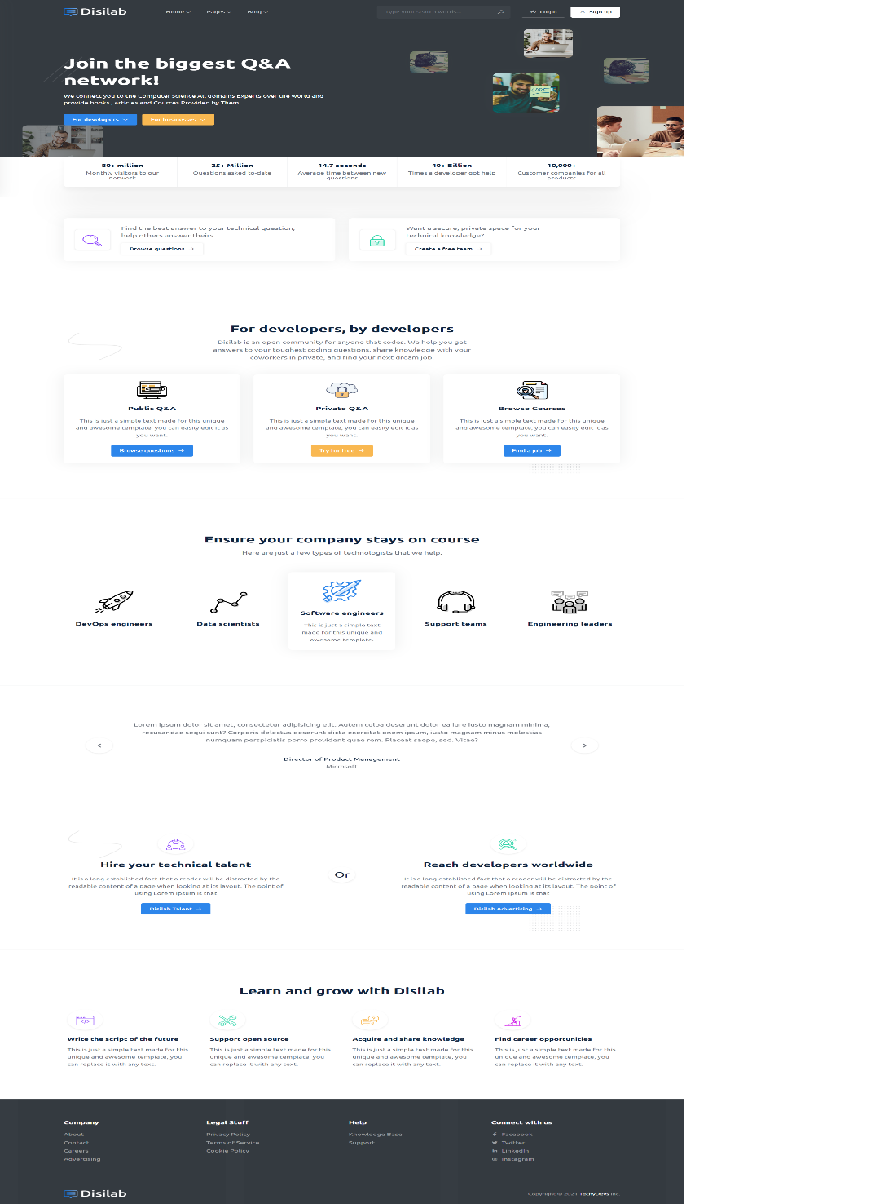

Figure 10 Home page

***Table 31 Home page of UI***

|  |  |
| --- | --- |
| **Purpose** | This is the landing of the system. whenever users login to the system , they reach the landing page of the system. |
| **Used HTML controls** | Button |
| **Associated tables** | ----------------------- |
| **Data In** | ----------------------- |
| **Data Out** | ----------------------- |
| **Validation** | ------------------------ |

**4.4 Dashboard of expert**

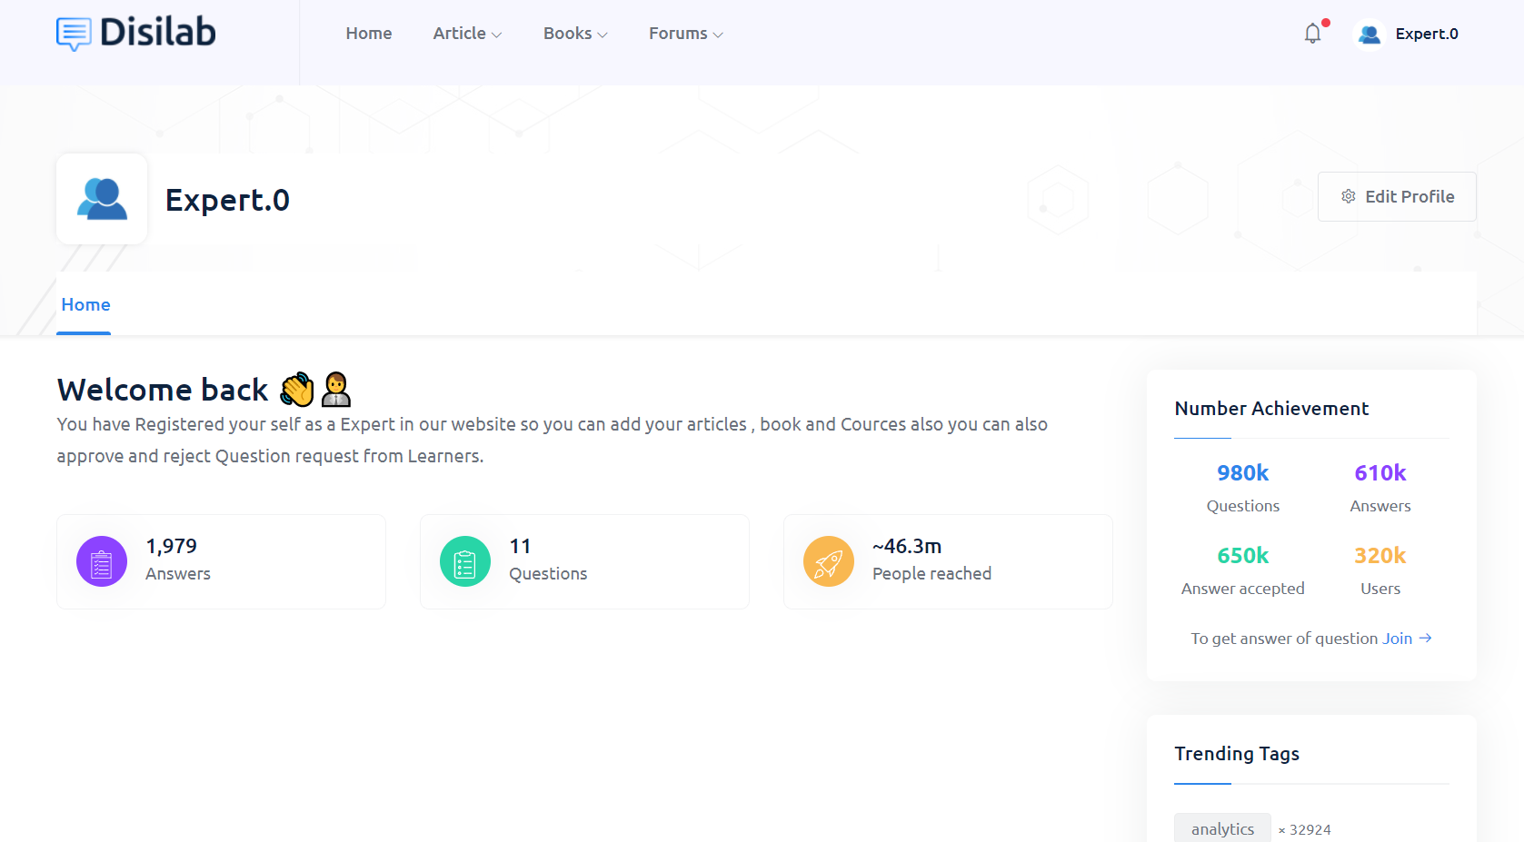

Figure 11 Dashboard of expert

***Table 32 Dashboard of expert***

|  |  |
| --- | --- |
| **Purpose** | This is the dashboard of domain extert. Expert can view their profile and also they can update it. |
| **Used HTML controls** | Button, Drop down |
| **Associated tables** | ----------------------- |
| **Data In** | ------------------------ |
| **Data Out** | ------------------------- |
| **Validation** | ------------------------- |

**4.5 Dashboard of learner**

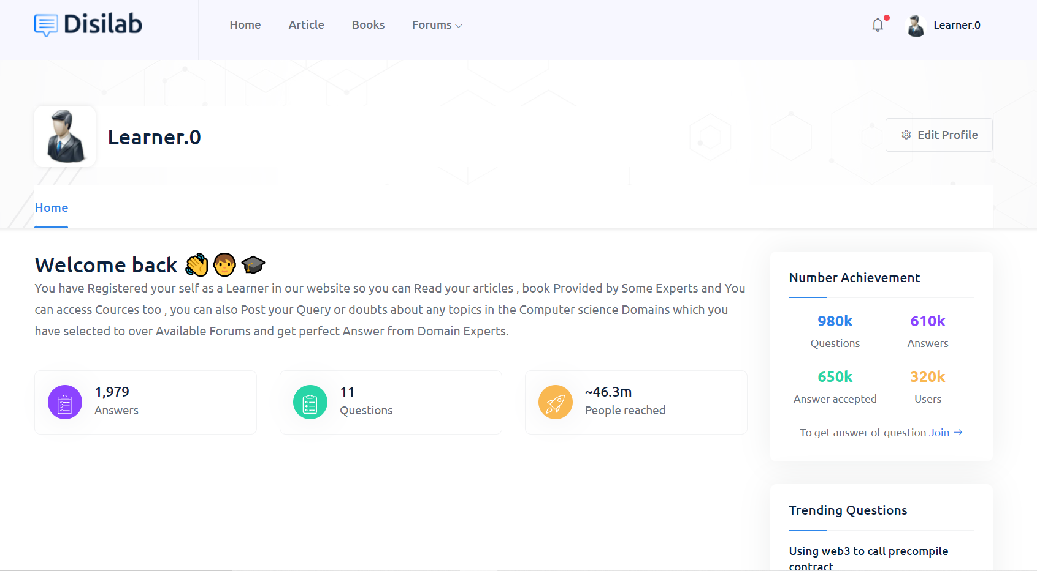

Figure 12 Dashboard of learner

***Table 33 Dashboard of learner***

|  |  |
| --- | --- |
| **Purpose** | This is the dashboard of learner. Expert can view their profile and also they can update it. |
| **Used HTML controls** | Button, Drop down |
| **Associated tables** | ----------------------- |
| **Data In** | ------------------------ |
| **Data Out** | ------------------------- |
| **Validation** | ------------------------- |

**4.6 Sign up page**



Figure 13 Sign up page

***Table 34 Sign up page***

|  |  |
| --- | --- |
| **Purpose** | This is a registration form of the system. whenever users fill up this form, they can log in to the system and reach the home page of the system. |
| **Used HTML controls** | Text box, Button, Radio button |
| **Associated tables** | Data_User |
| **Data In** | User_name, email_id, Password, user_type |
| **Data Out** | Data_expert, Data_learner |
| **Validation** | User name: - User name must be in alphabet  Email id: - Store email id that has at least one alphabet, one number and by default @gmail.com  Password: -Store password that has at least 1 upper case, one lowercase one number, and a special character and must be 8 characters |

**4.7 Login page**

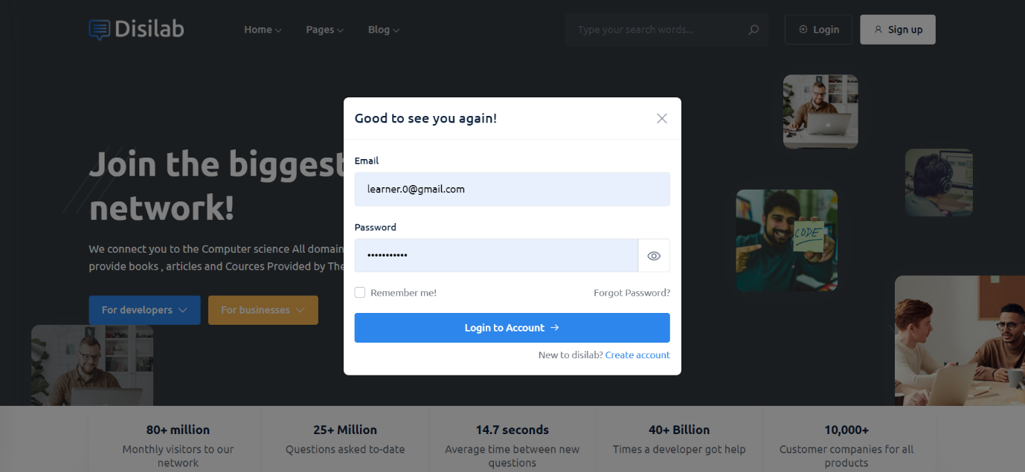

Figure 14 Login page

***Table 35 Login page***

|  |  |
| --- | --- |
| **Purpose** | This is the login page about the system. After filling up the registration form, the user can reach the login page. After login into the system, the user can reach the home page of the system. |
| **Used HTML controls** | Text box, Button |
| **Associated tables** | Data_user |
| **Data In** | User_name, Password |
| **Data Out** | home page |
| **Validations** | Email id: - Store email id that has at least one alphabet, one number and by default @gmail.com  Password: -Store password that has at least 1 upper case, one lowercase one number, and a special character and must be 8 characters |

**4.8 Article home page**

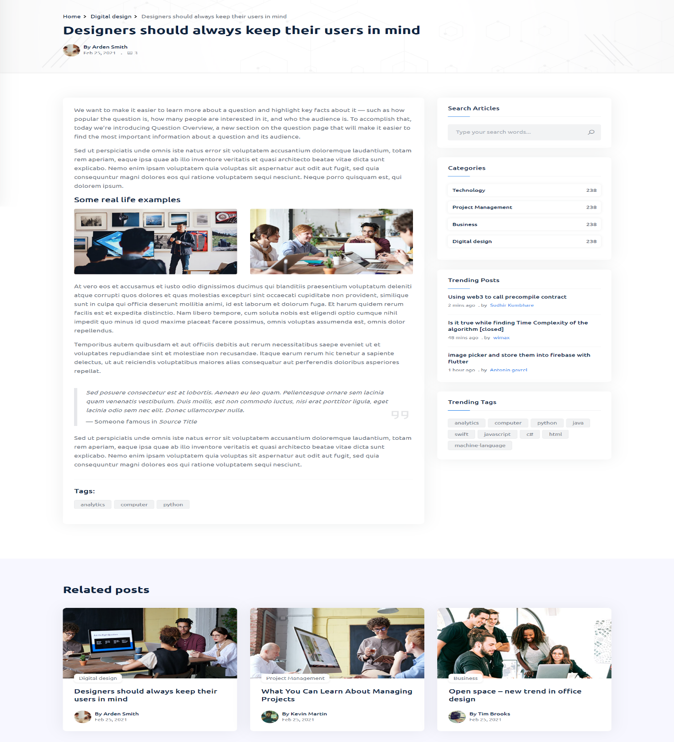

Figure 15 Article home page

***Table 36 Article home page***

|  |  |
| --- | --- |
| **Purpose** | This is the home page of article. User can use this page for read articles and expert can use this page for upload the articles. |
| **Used HTML controls** | Button, Navigation |
| **Associated tables** | ------------------------- |
| **Data In** | -------------------------- |
| **Data Out** | --------------------------- |
| **Validations** | --------------------------- |

**4.9 Article list page**

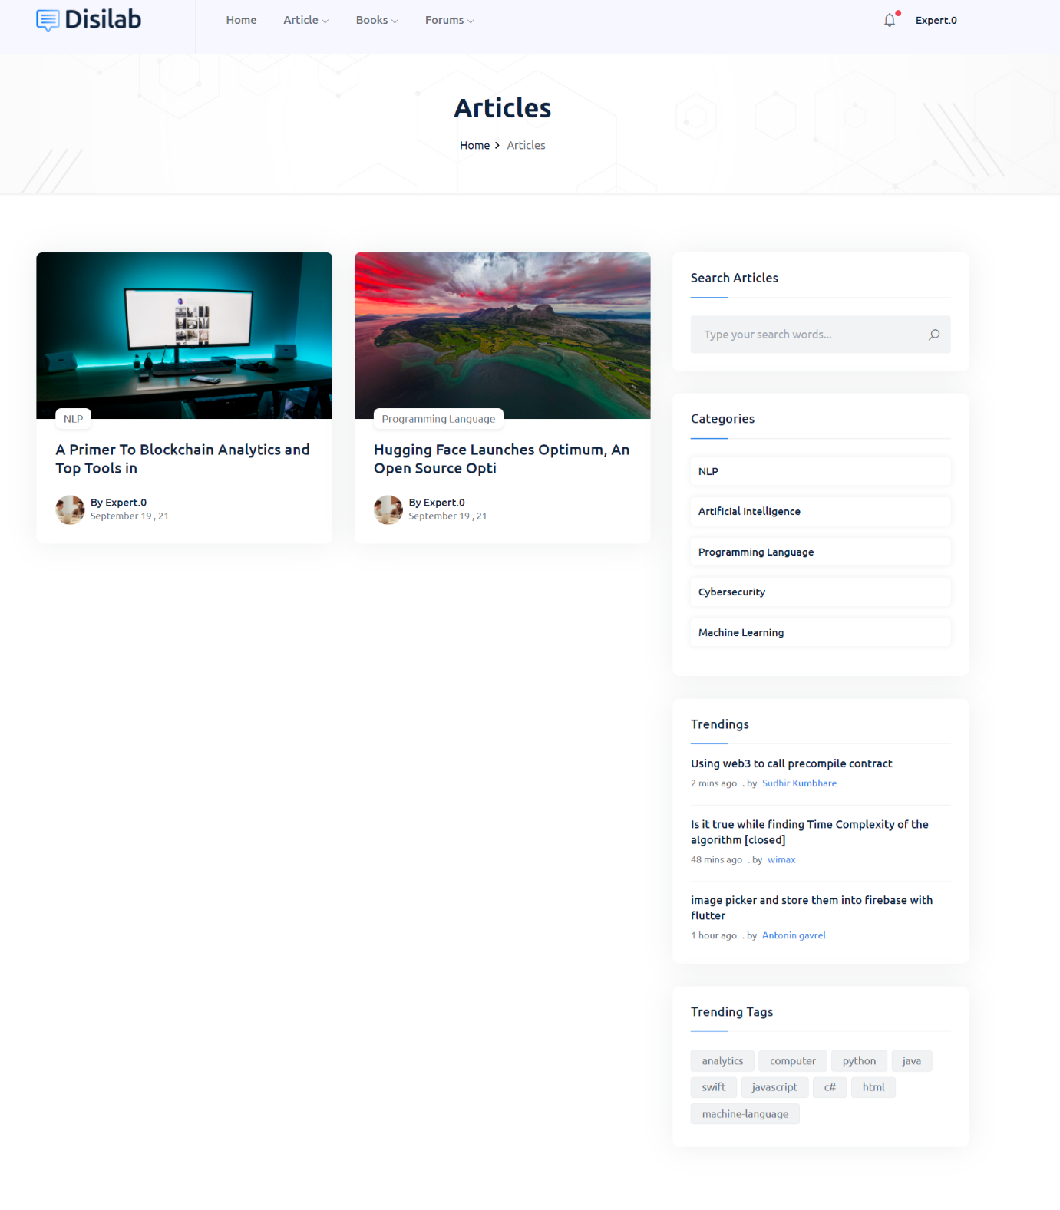

Figure 16 Article list page

***Table 37 Article list page***

|  |  |
| --- | --- |
| **Purpose** | This is the list page of article. User can use this page for see articles list and also search the any article using this page. |
| **Used HTML controls** | Search box, Button, Navigation |
| **Associated tables** | ------------------------ |
| **Data In** | ----------------------- |
| **Data Out** | ------------------------ |
| **Validations** | ----------------------- |

**4.10 Book home page**

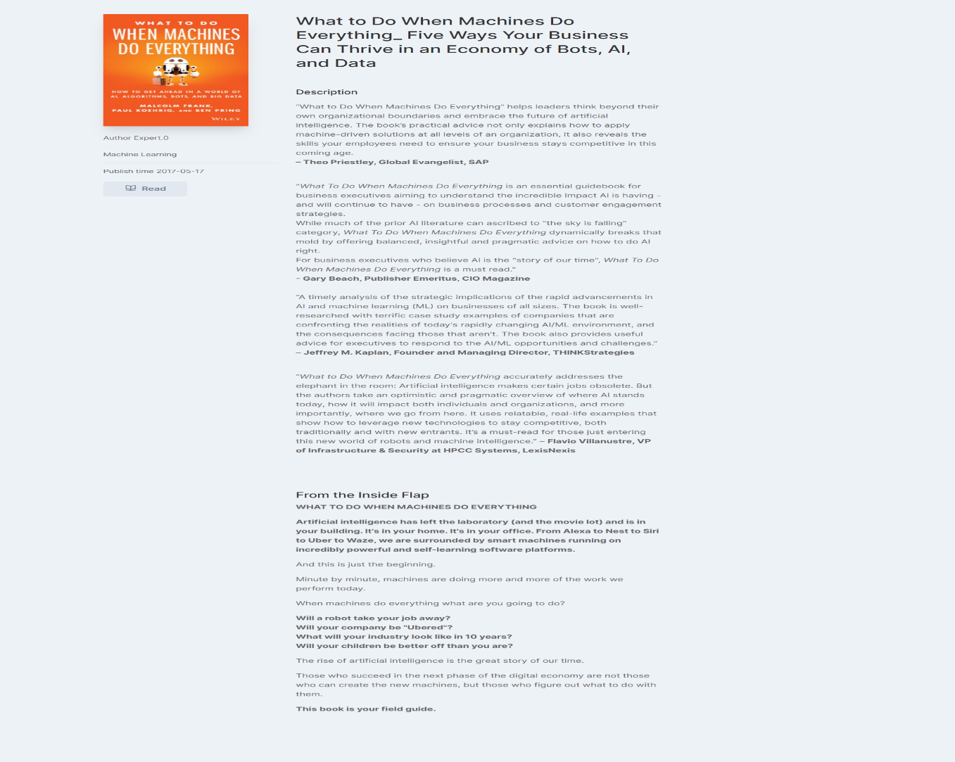

Figure 17 Book home page

***Table 38 Book home page***

|  |  |
| --- | --- |
| **Purpose** | This is the home page of book. Learner can read book and expert can upload the book using this page. |
| **Used HTML controls** | Button, Navigation |
| **Associated tables** | ------------------- |
| **Data In** | ------------------- |
| **Data Out** | ------------------- |
| **Validations** | ------------------- |

**4.11 Book list page**

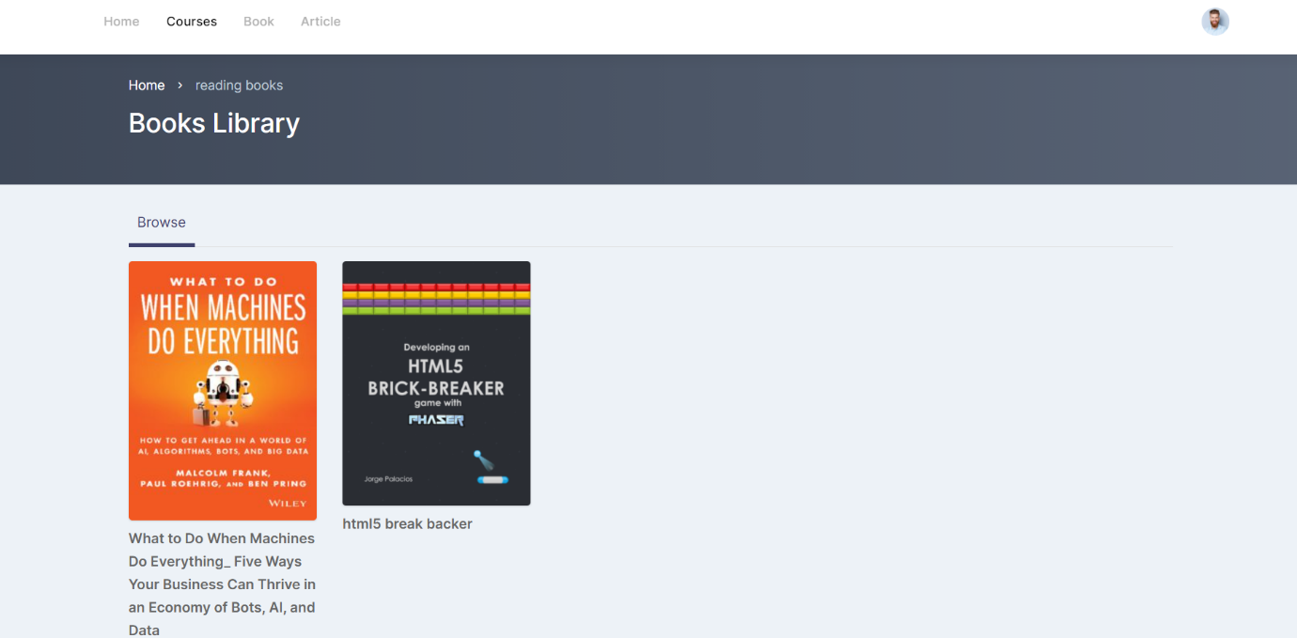

Figure 18 Book list page

***Table 39 Book list page***

|  |  |
| --- | --- |
| **Purpose** | This is the list page of book. Learner can see the all list of book using this page. |
| **Used HTML controls** | Button, Navigation |
| **Associated tables** | ------------------ |
| **Data In** | ------------------ |
| **Data Out** | ------------------ |
| **Validations** | -------------------- |

**4.12 Course list page**

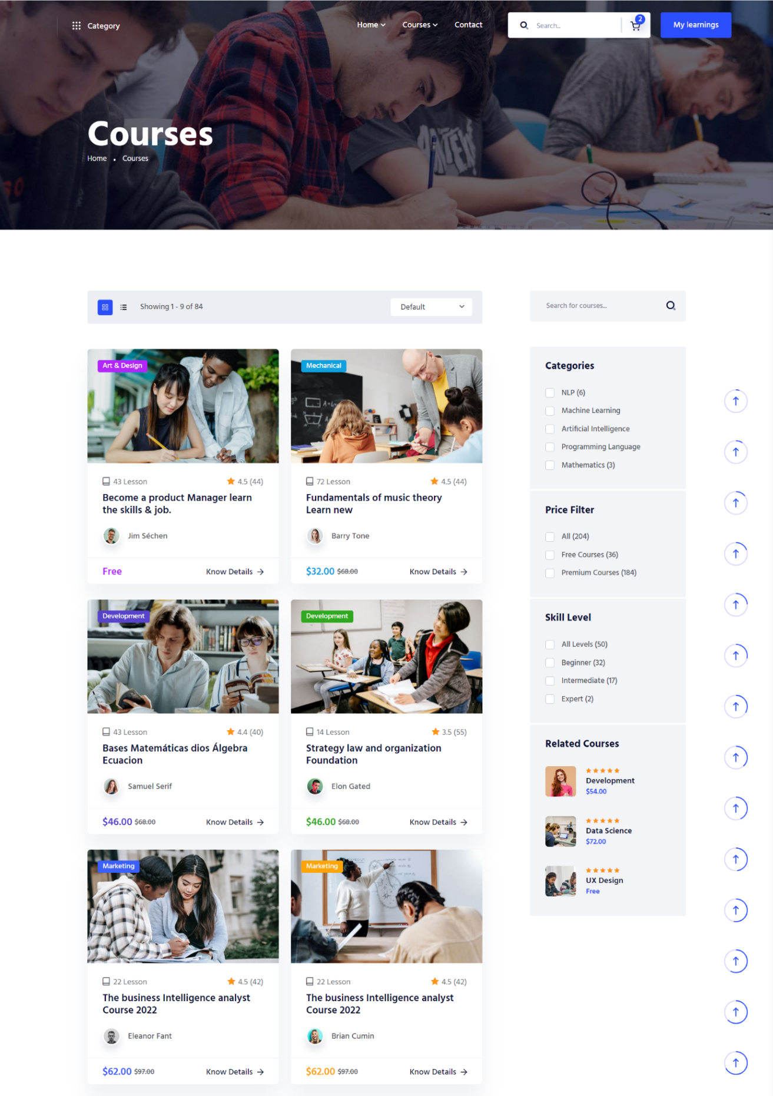

Figure 19 Course list page

***Table 40 Course list page***

|  |  |
| --- | --- |
| **Purpose** | This is the list page of course. Learner can see all the list of course and study on it. |
| **Used HTML controls** | Search box, check box, Drop down, Navigation |
| **Associated tables** | ------------------- |
| **Data In** | ------------------- |
| **Data Out** | ------------------ |
| **Validations** | ------------------ |

**4.13 Course single page**

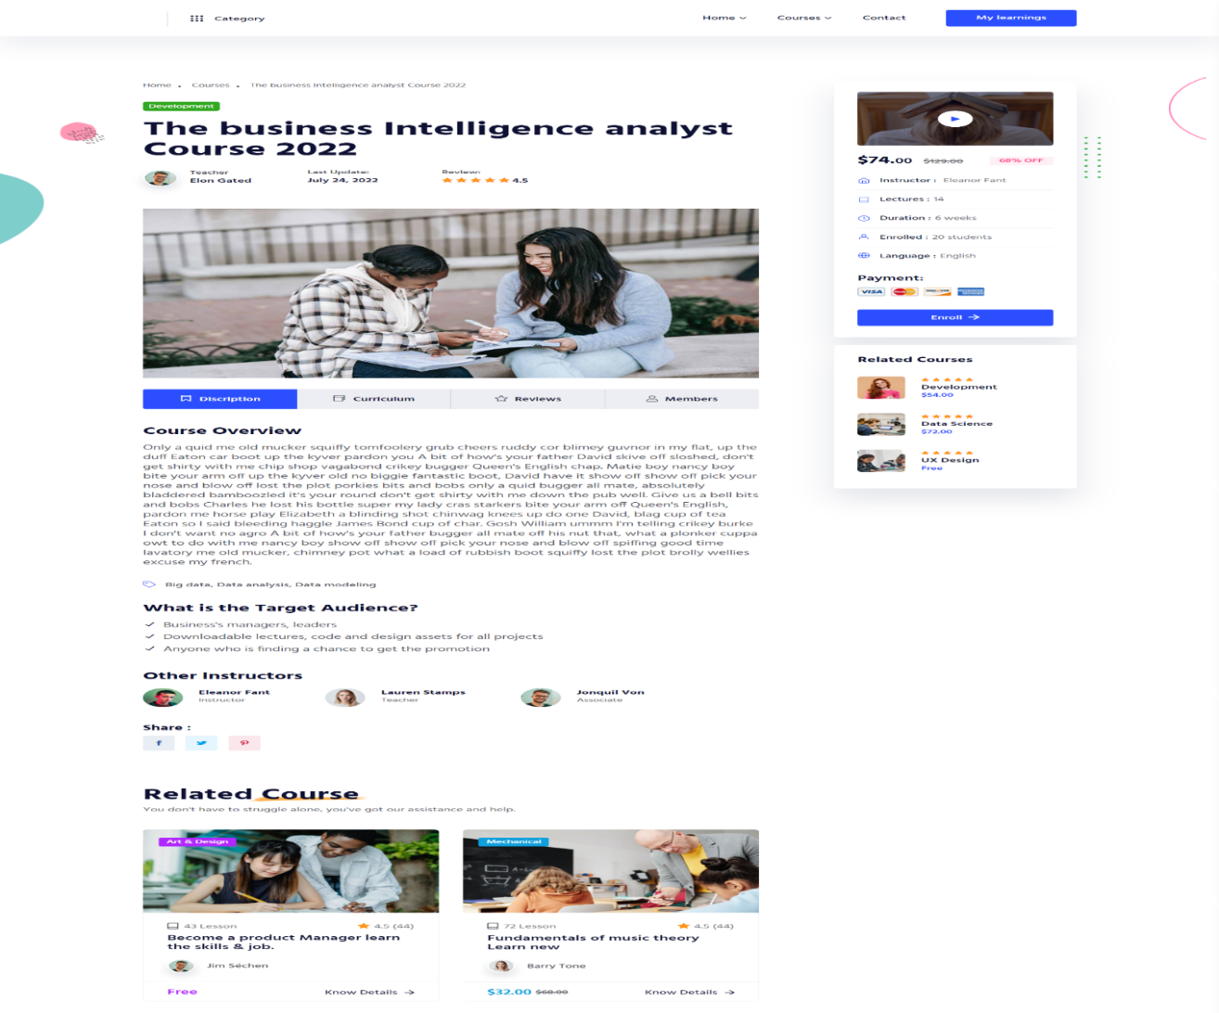

Figure 20 Course single page

***Table 41 Course single page***

|  |  |
| --- | --- |
| **Purpose** | This is the page of course. Learner can study on particular course which are available in this system. |
| **Used HTML controls** | Navigation, Button |
| **Associated tables** | ------------------ |
| **Data In** | ------------------- |
| **Data Out** | ------------------ |
| **Validations** | ------------------ |

**4.14 Question draft page**

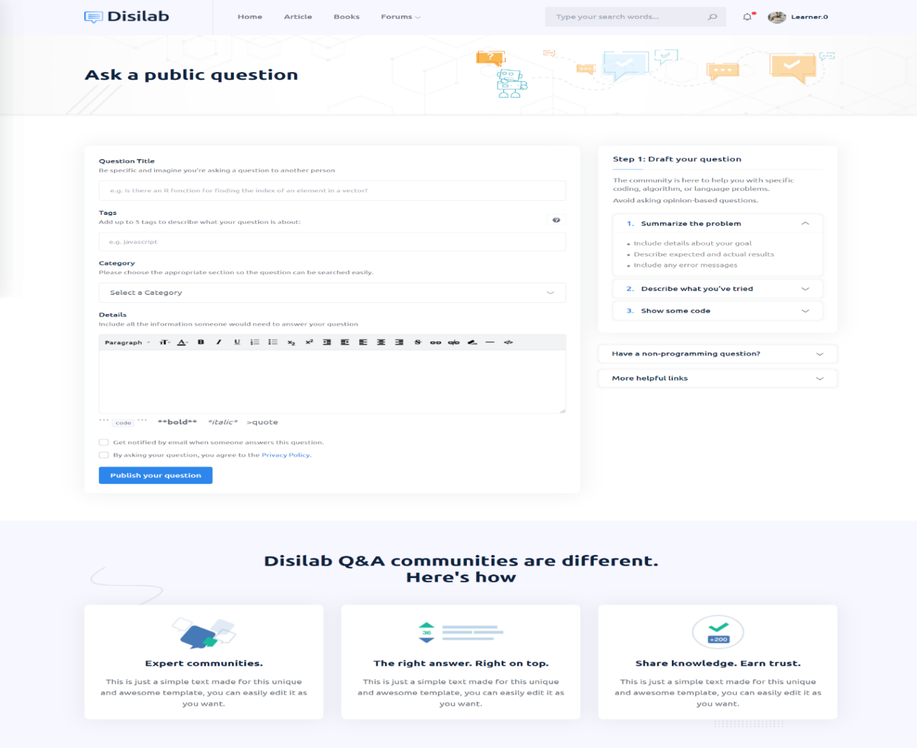

Figure 21 Question draft page

***Table 42 Question draft page***

|  |  |
| --- | --- |
| **Purpose** | This is the draft page of forum. Using this editor, learner can upload their question and expert can give the answer of particular question. |
| **Used HTML controls** | Text box, Button, Navigation, Drop-down, Check box |
| **Associated tables** | Data_fo_que |
| **Data In** | fo_que_title, fo_question |
| **Data Out** | Home page of forum |
| **Validations** | ---------------------- |

**4.15 Online compiler**

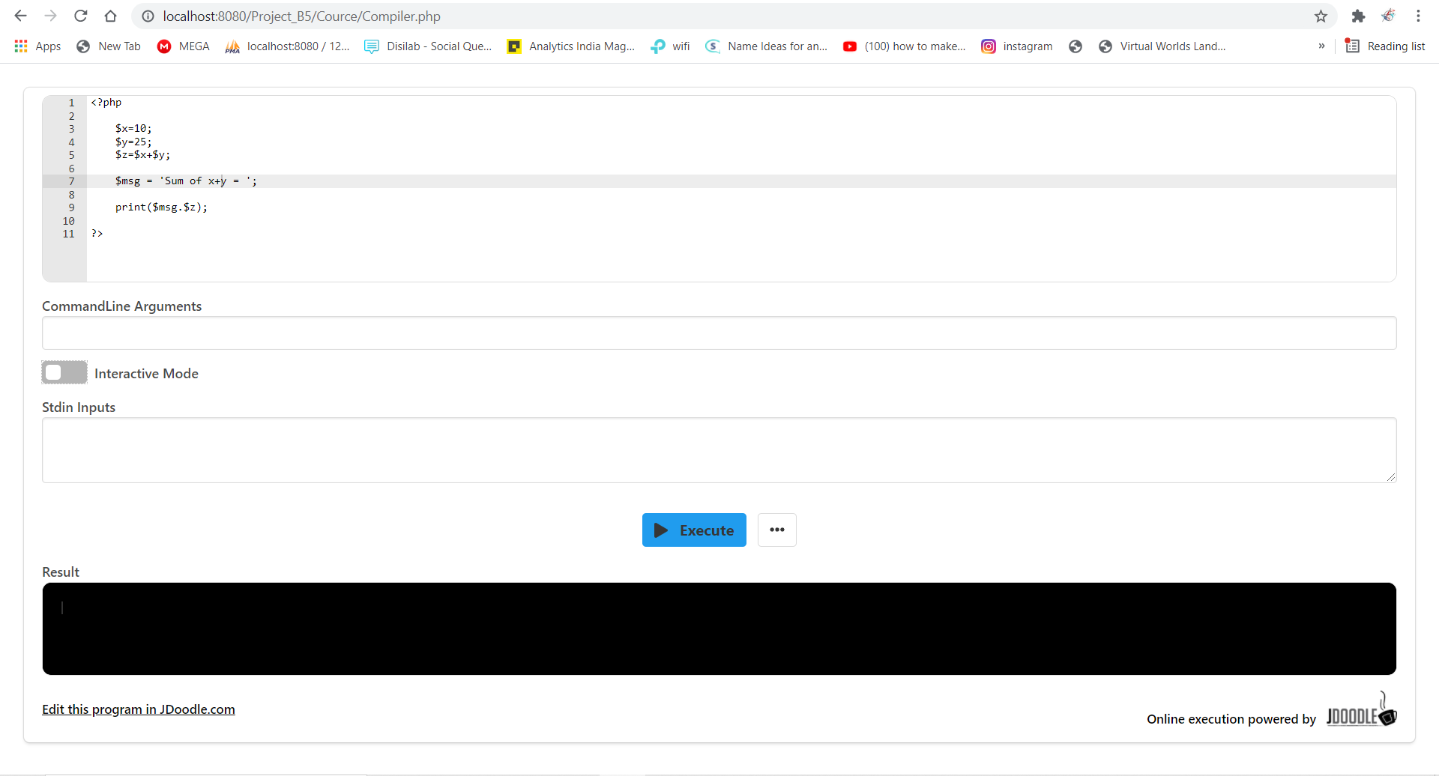

Figure 22 Online compiler page

***Table 43 Online compiler page***

|  |  |
| --- | --- |
| **Purpose** | This is the page of online compiler. Using this compiler, learner can compile their code without download any IDE. |
| **Used HTML controls** | ------------------------ |
| **Associated tables** | ------------------------- |
| **Data In** | Code |
| **Data Out** | output of the code |
| **Validations** | ---------------------- |

**4.16 Payment gateway: -**

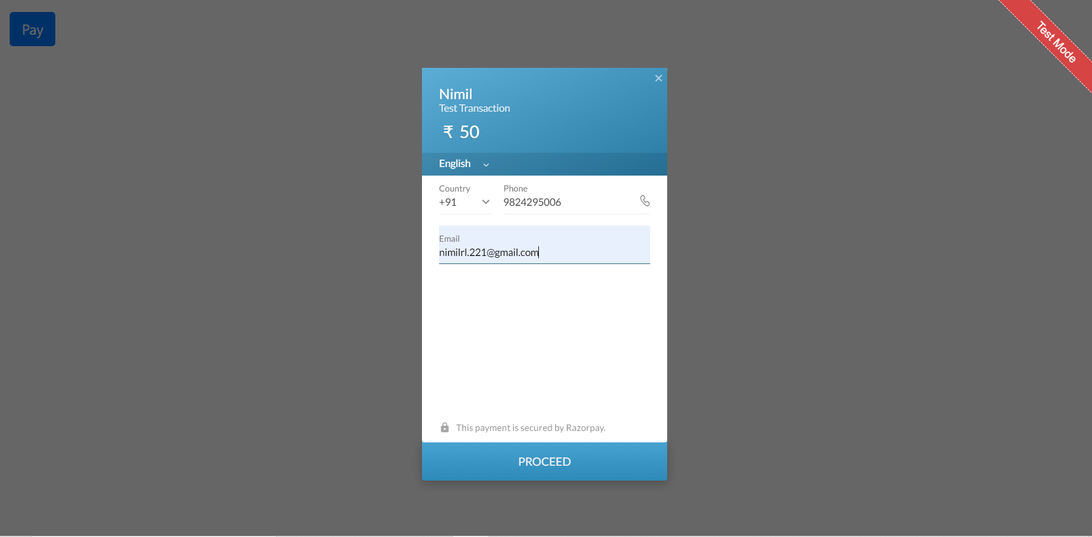

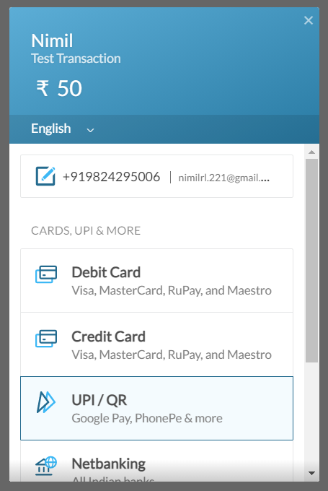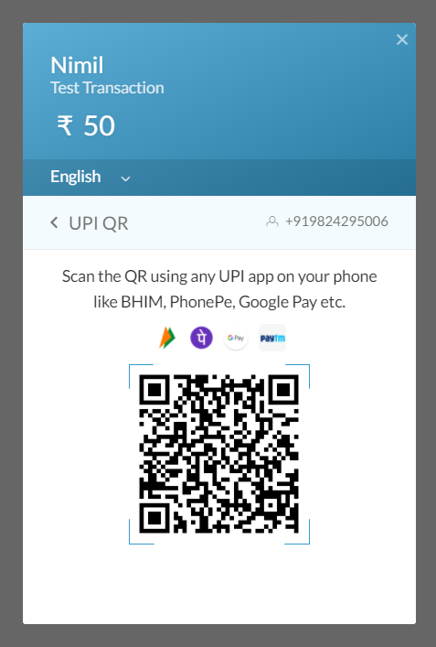

Figure 23 Payment gateway page

***Table 44 Pyament gateway page***

|  |  |
| --- | --- |
| **Purpose** | This is the page of payment gateway. Using this features, learner can pay money for course. |
| **Used HTML controls** | ------------------------ |
| **Associated tables** | ------------------------- |
| **Data In** | Email-id |
| **Data Out** | Process start |
| **Validations** | ---------------------- |

1. **System Testing**
   1. **Registration page test report**

***Table 45 Registration page test report***

|  |  |  |  |  |  |  |
| --- | --- | --- | --- | --- | --- | --- |
| **Test Description** | **Element** | **Selenese** | **Target** | **Value (Expected)** | **Actual value (As per Log)** | **Test Description** |
| Verify value | Input box | Click and verify | name=txtemail | nimilrl.221@gmail.com | nimilrl.221@gmail.com | Pass |
| Verify value | Input box | Click and verify | name=txtusername | dhameliya02@gmail.com | dhameliya02@gmail.com | Pass |
| Verify store value | Input box | Click and verify | name=txtpassword | password | password | Pass |
| Verify value present or not | Input box | Click and verify | name=btnsignup | Next | Next | Pass |

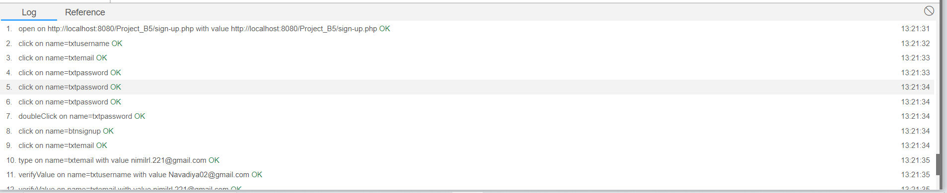

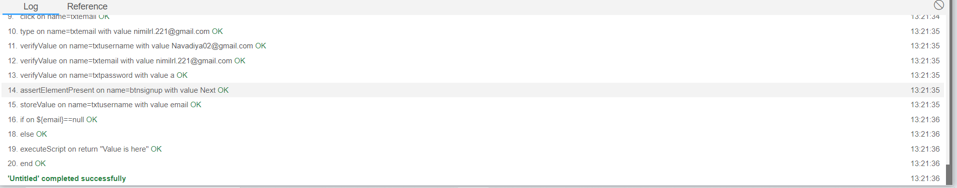

Figure 24 Registration page test report

* 1. **Learner registration page test report**

***Table 46 Learner registration page test report***

|  |  |  |  |  |  |  |
| --- | --- | --- | --- | --- | --- | --- |
| **Test Description** | **Element** | **Selenese** | **Target** | **Value (Expected)** | **Actual value (As per Log)** | **Test Description** |
| Verify value | Input box | Click and verify | name=txtdob | 20-10-2021 | 20-10-2021 | Pass |
| Verify value | Input box | Click and verify | name=txtcontact | 8488573747 | 8488573747 | Pass |
| Verify store value | Input box | Click and verify | name=Password | password | password | Pass |
| Verify input field. | Input box | Click and verify | name=txtemail | vruti061@gmail.com | vruti061@gmail.com | Pass |

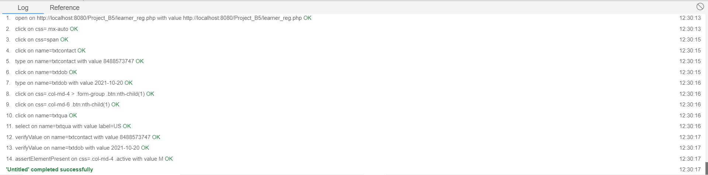

Figure 25 Learner registration page test report

1. **References**

* <https://docs.jdoodle.com/>
* <https://www.javatpoint.com/creating-mysql-database-with-xampp>
* <https://www.apachefriends.org/faq_windows.html>
* <http://httpd.apache.org/docs/>
* <https://www.php.net/docs.php>
* <https://developer.mozilla.org/en-US/docs/Web/HTML>
* <https://dev.mysql.com/doc/>